**Roadmap for Form Fillings Vernacular Voyage with Voice Versatility**

**Project Overview**

The "Form Fillings Vernacular Voyage with Voice Versatility" project aims to transform the way frontline workers (FLWs) complete forms by integrating advanced voice recognition and language processing technologies. By leveraging GPT and Azure OpenAI, the solution will enable FLWs to fill forms in their native languages through voice commands, significantly reducing time spent on form-filling and overcoming language barriers.

**Key Milestones**

*1. Project Initiation*

- Project Scope Discussion

- Assignment of roles and responsibilities

- Document sharing (use cases, objectives)

2. *Software Setup*

- Installation of required software on project laptops

- Addressing initial queries

3. *tools and Programming Discussion*

- Discussion on selected programming languages and tools

- Assignments for team members

4. *Prototype Development*

- Design and develop the initial prototype of the voice-enabled form-filling application

- Integrate language processing capabilities

5. *testing Phase*

- Conduct user testing with frontline workers

- Gather feedback and iterate on the prototype

6. *Final Deployment*

- Finalize the application based on testing feedback

- Deploy the application for use in the field

7. *Post-Deployment Review*

- Collect performance data

- Review user experience and make necessary adjustments

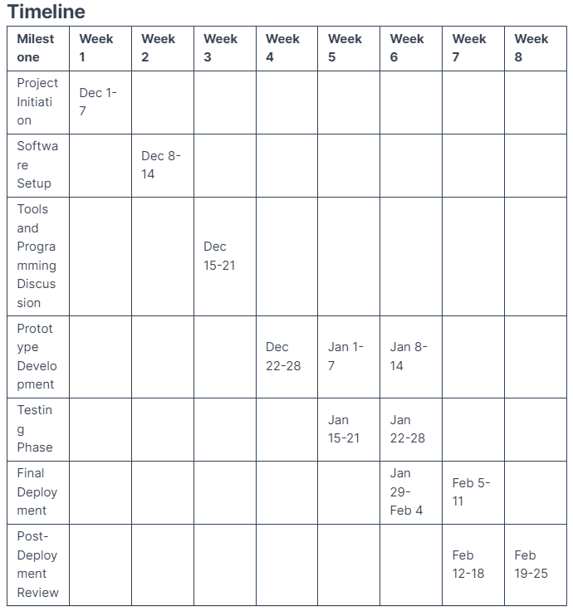

|  |  |
| --- | --- |
| Phase | Resources Needed |
| Project Initiation | Project manager, business analyst, documentation tools |
| Software Setup | Laptops, software licenses, IT support |
| Tools and Programming Discussion | Team of developers, programming tools (IDE, libraries) |
| Prototype Development | Development team, access to GPT and Azure OpenAI |
| Testing Phase | Frontline workers for testing, feedback tools |
| Final Deployment | IT support for deployment, training materials |
| Post-Deployment Review | Analytics tools, user feedback channels |

This roadmap outlines a structured approach for the "Form Fillings Vernacular Voyage with Voice Versatility" project, ensuring all phases are planned and resources are adequately allocated while addressing potential risks and success metrics.